# Google cloud console Documentation

Step1: Go to the website: <https://search.google.com/search-console/welcome>

Now insert the company website without any ‘/’ or ‘https://’

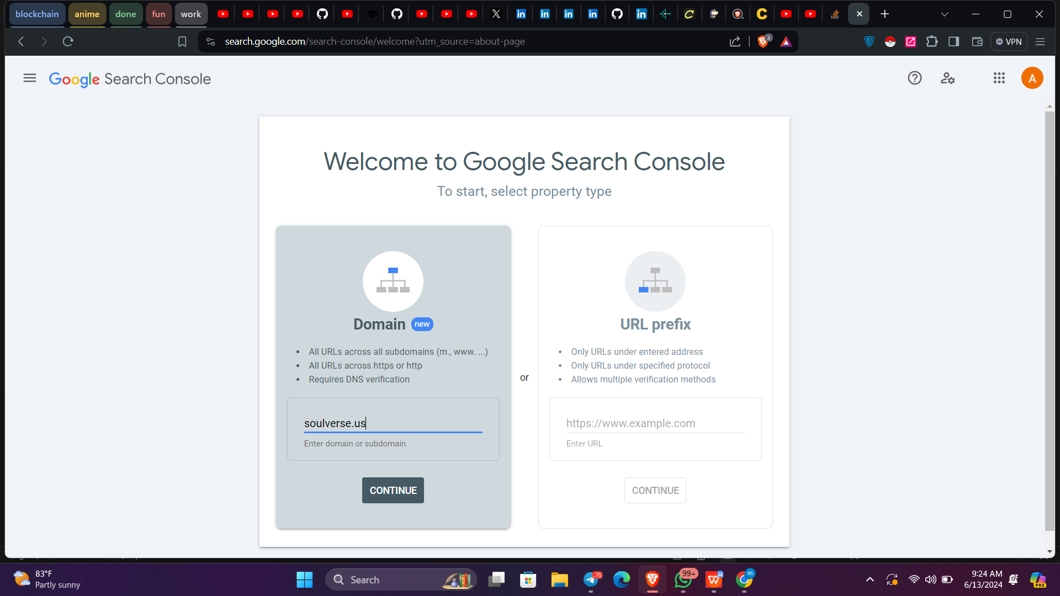

We can also use this method for easier insertion of verification

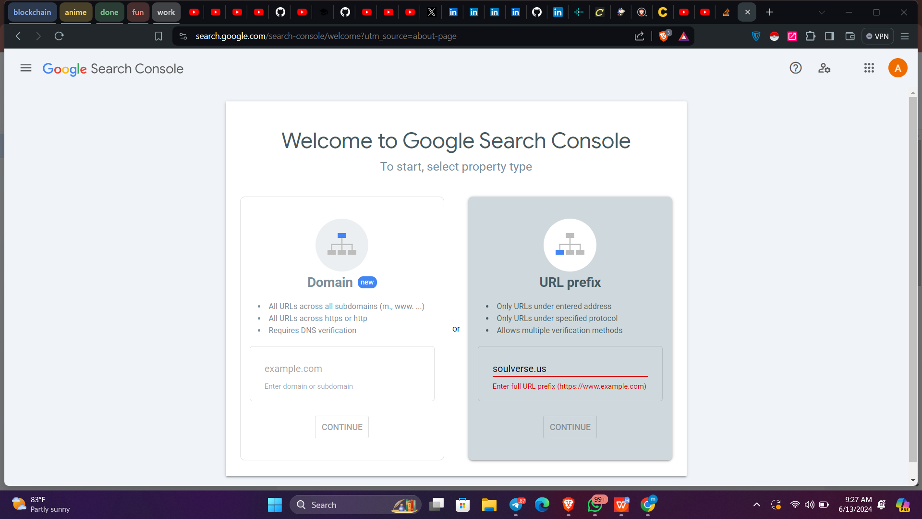

Just add this verification tag in your code for easy automatic verification

Tag looks like -> <meta name="google-site-verification" content="LaLEIeVLOSsxq-Go-63l2SGplSOh9LDdk7L5OThykqM" />

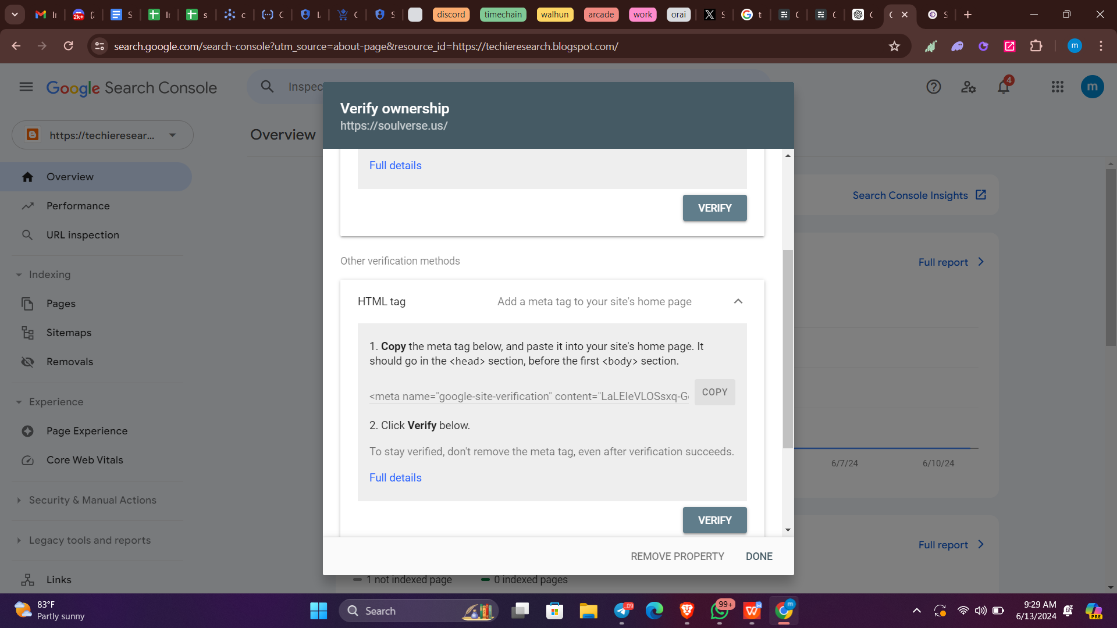

After this paste the tag in the code

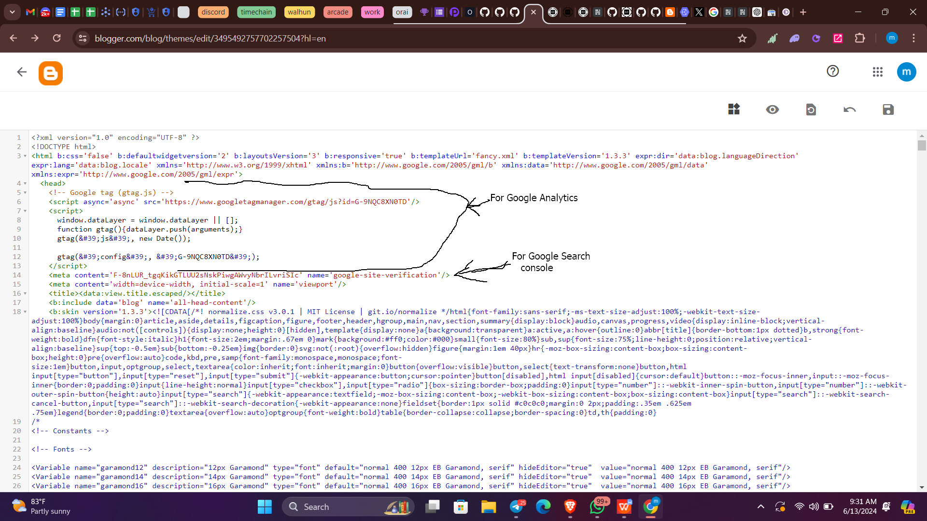

AS you can see we have inseted the verification code and now er just need to verify.  
After verifying our console will get updated with data   
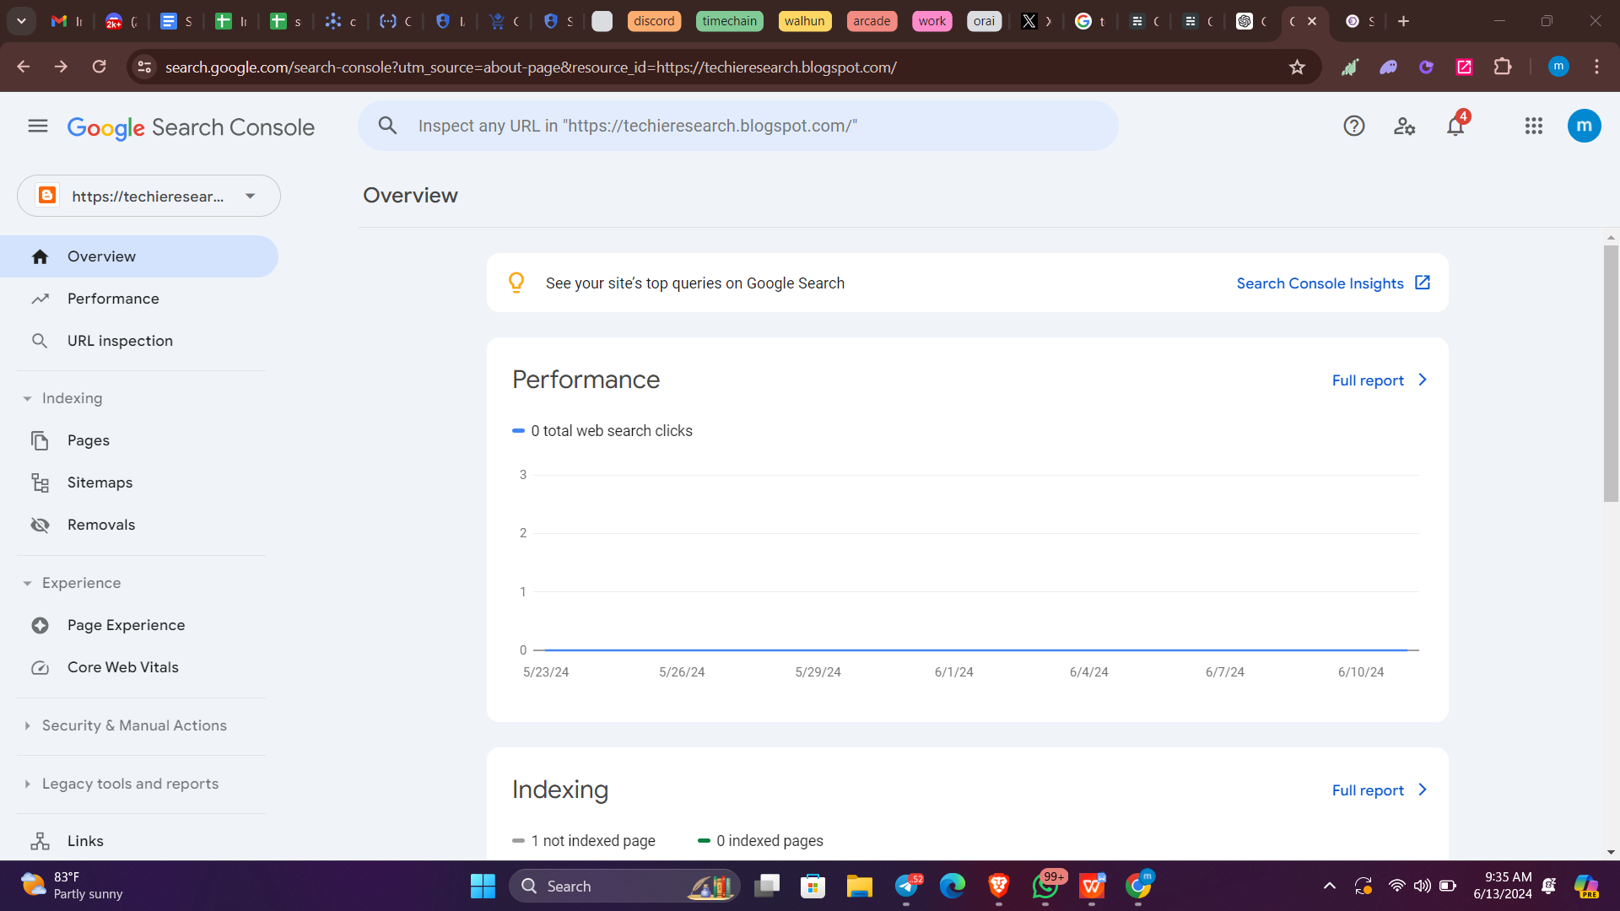

Step2: Now go to the google cloud

In google cloud select the hamburger menu >> ApI & Services >> Credentials

Here create a new OAuth 2.0 Client ID And download the json

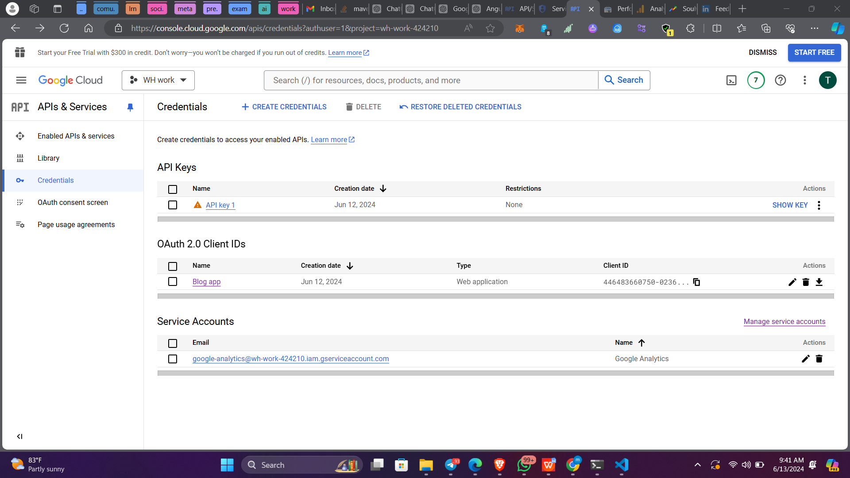

You Can create the OAuth Client by using “ + Create Credentials “

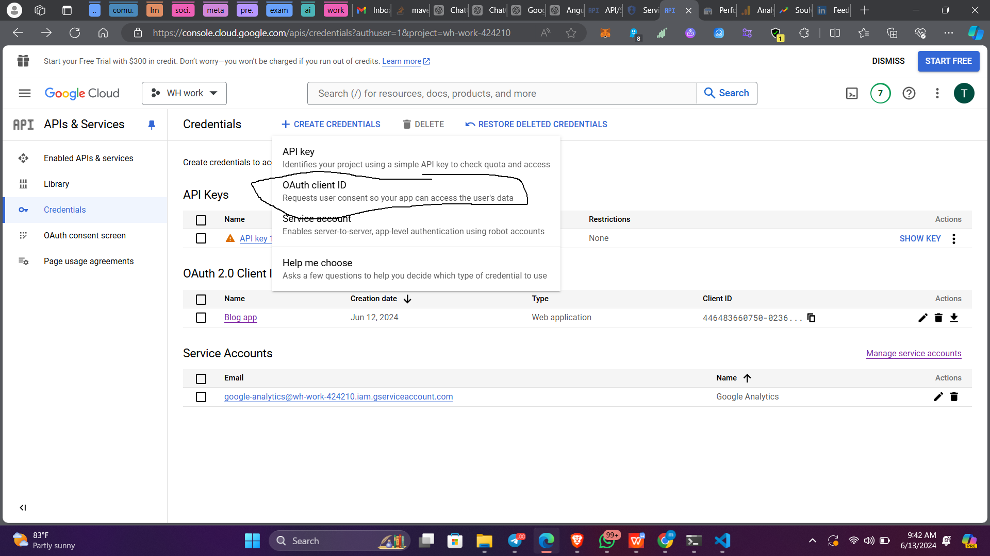

And Fill in the details Also please add ‘http://localhost:8080/’ in redirect URI’s else it wont work.

